**Experiment No: 16**

**Name of the Experiment:** Study of Heun’s Method to Solve Ordinary Differential Equation(s) (Initial Value Problem)

**Objectives:** The objective of this experiment is to use Heun’s Method to Solve Ordinary Differential Equation(s) with Initial Value, using MATLAB.

**Theory:**

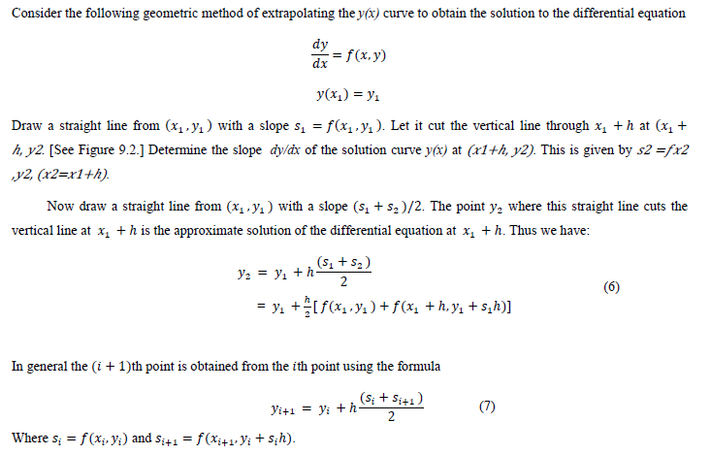

**Tool:** MATLAB Software

**Methodology:**

**Problem:** The temperature radiation of a ball in air at ambient temperature 300K can be describe by the differential equation

$\frac{d∅}{dx}$ = −𝟐. 𝟐𝟎𝟔𝟕 × 𝟏𝟎-𝟏𝟐(∅𝟒 − 𝟖𝟏 × 𝟏𝟎𝟖)

Using Euler’s method find the temperature of the ball at 𝒕 = 𝟒𝟖𝟎 seconds where ∅ is in K and t in second. It is assumed that the initial temperature of the ball is 1200K.

**MATLAB Code:**

clear all;

close all;

clc;

f=@(x,y)-2.2067*10^-12*(y^4-81*10^8);

h=60;

n=7;

y0=1200;

x0=0;

xi=x0;

yi=y0;

for i=0:n

s1=f(xi,yi);

s2=f(xi+h,yi+s1*h);

yi=yi+h/2*(s1+s2);

xi=xi+60;

end

xi

yi

**Output:**

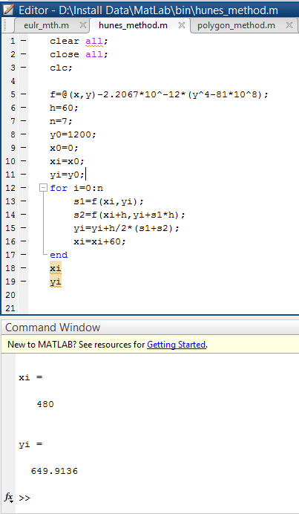

**Result(s)& Discussion:** The result is ∅(480) = ∅8= 649.9136K

**Conclusion:** the result is not the exact value as we find from polygon method but near that value. There are some error.

**References:**

[1] PDF given by **Prof. Dr. Md. Shamim Anower**